**Executive Summary**

**Team-7**

This report synthesizes data across various distinct exhibits, each providing critical insights into supplier performance, inventory management, and production processes for fabricated goods. The aim is to assist in strategic decision-making by identifying opportunities for optimization and enhancement in the supply chain and production lines.

*Data Exhibit 1:* Supplier Performance Evaluation

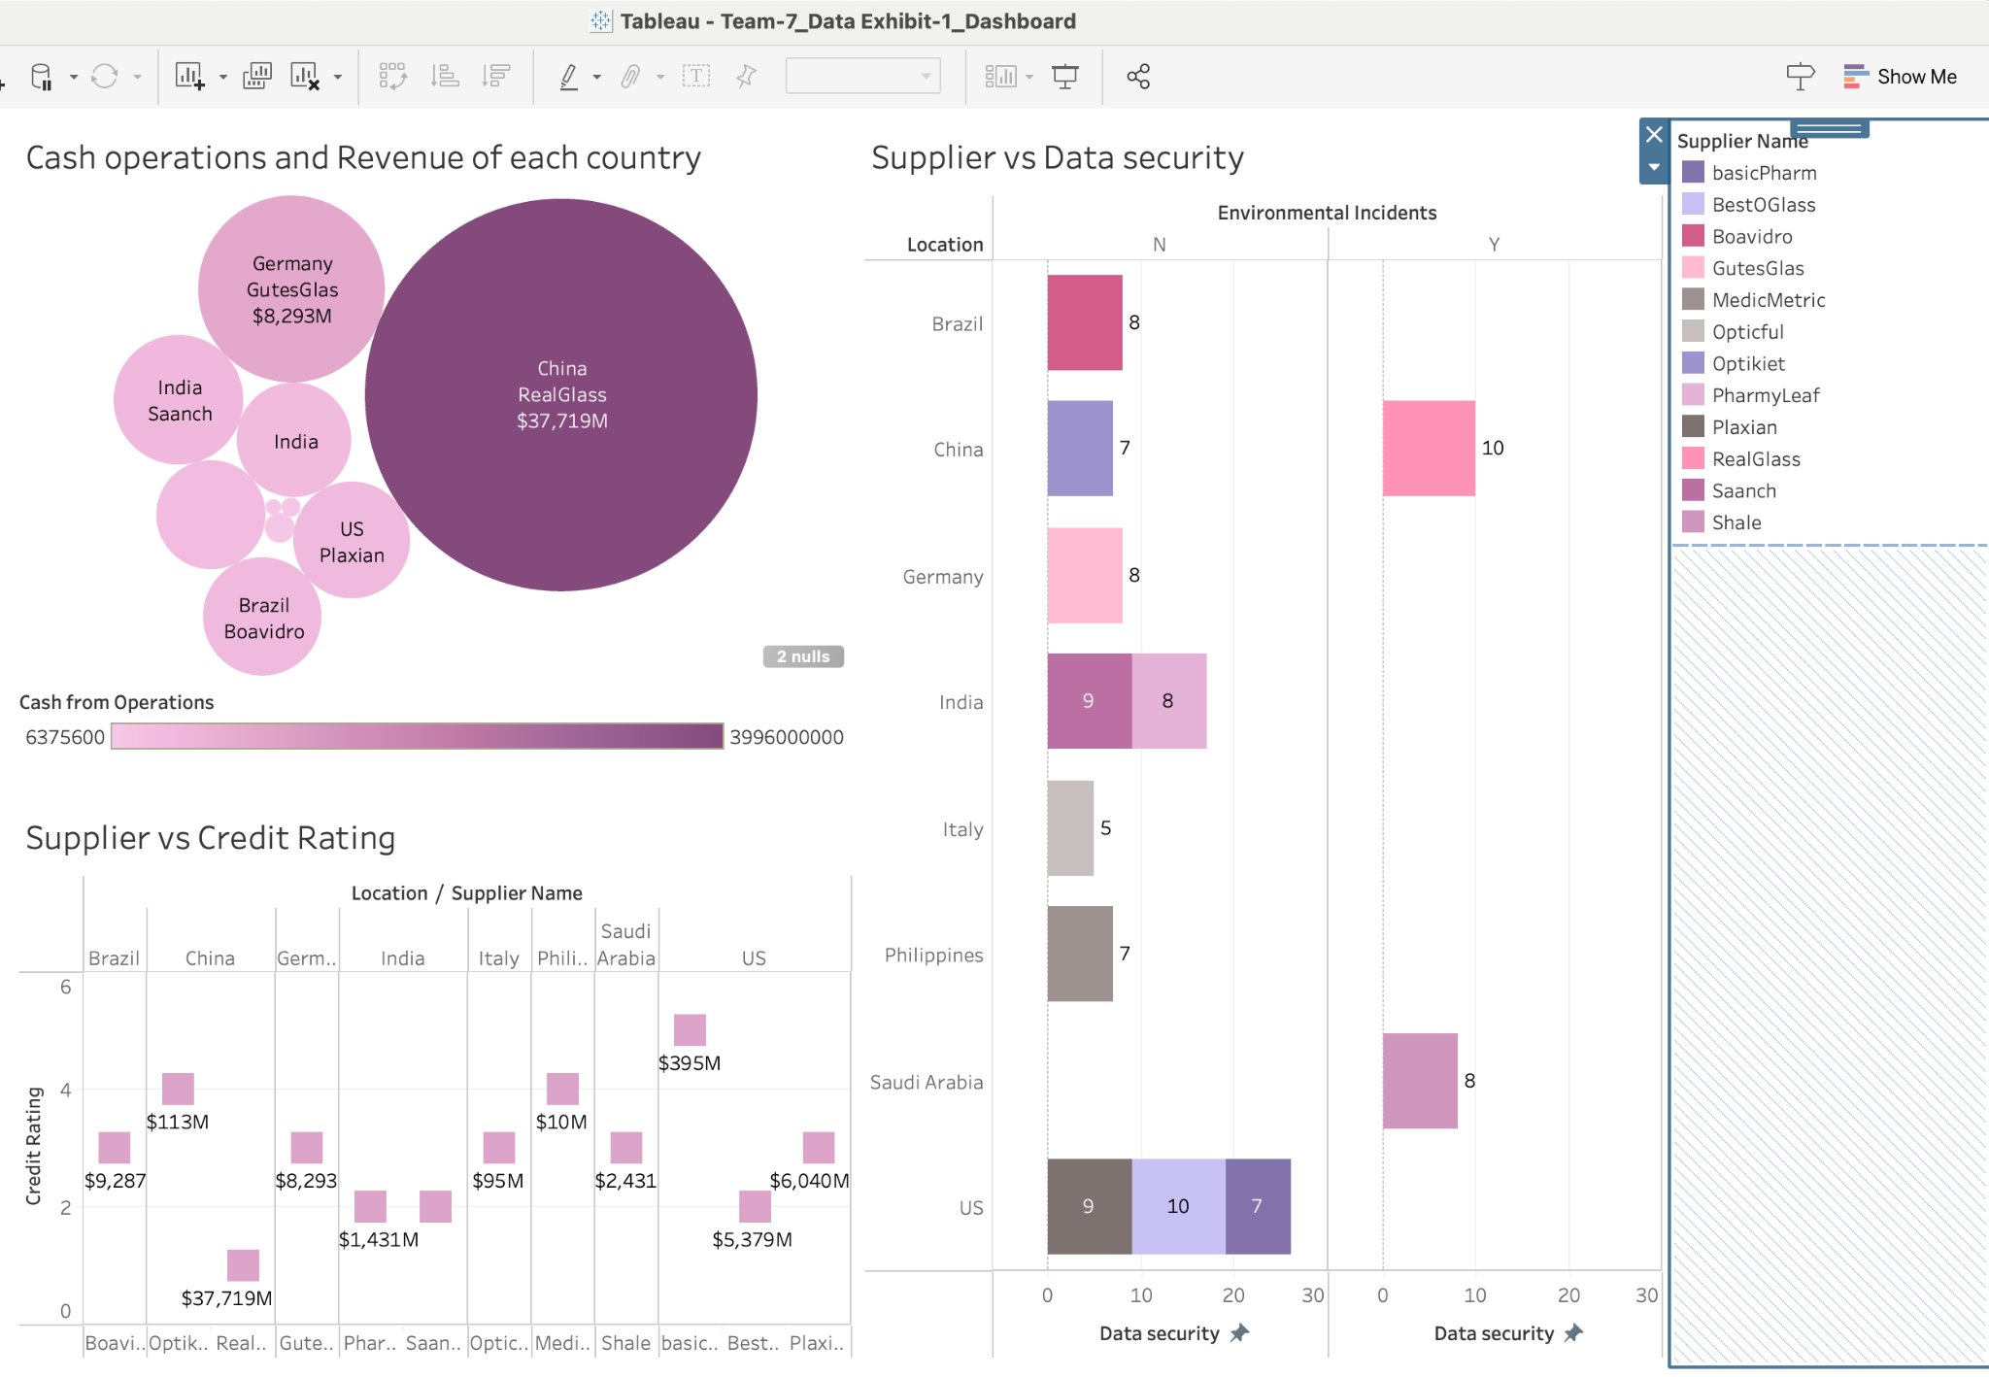

The first data exhibit presents a detailed comparison of supplier performance metrics including credit ratings, data security, and cash operations across various global locations, including Brazil, Germany, Italy, the Philippines, Saudi Arabia, China, India, and the United States.

* The square plot illustrates that credit ratings among suppliers vary significantly, with ratings ranging from 1 to 5. The highest-rated supplier, Basic Pharm in the United States, holds a credit rating of 5, indicative of strong financial health and reliability. Conversely, Real Glass in China holds the lowest rating of 1, pointing to potential financial instability or risk. The disparity in ratings suggests a need to reassess supplier relationships and potentially diversify the supplier base to mitigate risk.
* Data security is critical in maintaining the integrity of sensitive information. The analysis shows that Real Glass in China and Best O Glass in the US maintain the highest data security ratings, suggesting robust security measures are in place. However, the supplier Optical in the US has the lowest rating at 5, highlighting a vulnerability that requires immediate attention to enhance security protocols.
* The colour-coded map for cash operations indicates that Real Glass in China not only manages substantial cash operations exceeding $37,000M but also significantly surpasses other suppliers. This high level of cash operations could indicate a strong market position or effective cash management strategies. On the other end, Pharma Leaf in India shows the least cash operations at $1,431M, which could suggest limited financial flexibility or a smaller operational scale.

*Data Exhibit 2:* Inventory Management of Glassworks INC

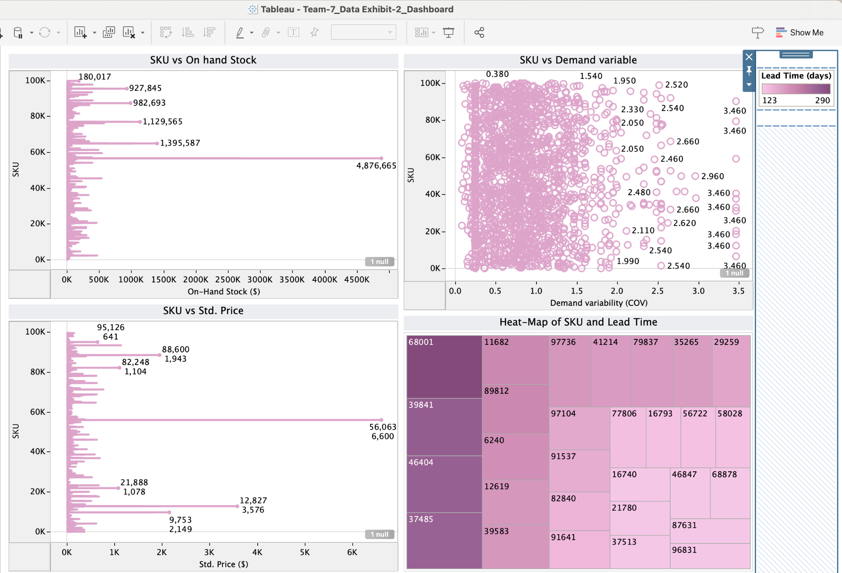

The second exhibit focuses on the inventory management for Glassworks INC, providing a deep dive into SKU-based inventory levels, pricing, and lead times.

* The plot reveals significant variability in inventory units among different SKUs. The highest inventory is held by SKU 56,722 with 925,539 units, suggesting potential overstocking and inefficiency in inventory turnover. Such substantial inventory levels highlight the need for strategic inventory reduction and optimization to manage holding costs effectively.
* The heat map shows a strong correlation between SKU numbers and lead times, identifying SKU 68001 with a maximum lead time of 290 days. This extended lead time can negatively impact supply chain responsiveness and customer satisfaction. Additionally, the pricing range from $5 to $6,600 per unit suggests a complex pricing strategy that requires careful management to maintain profitability.

*Data Exhibit 3:* Demand and Production Process Analysis for Fabricated Goods

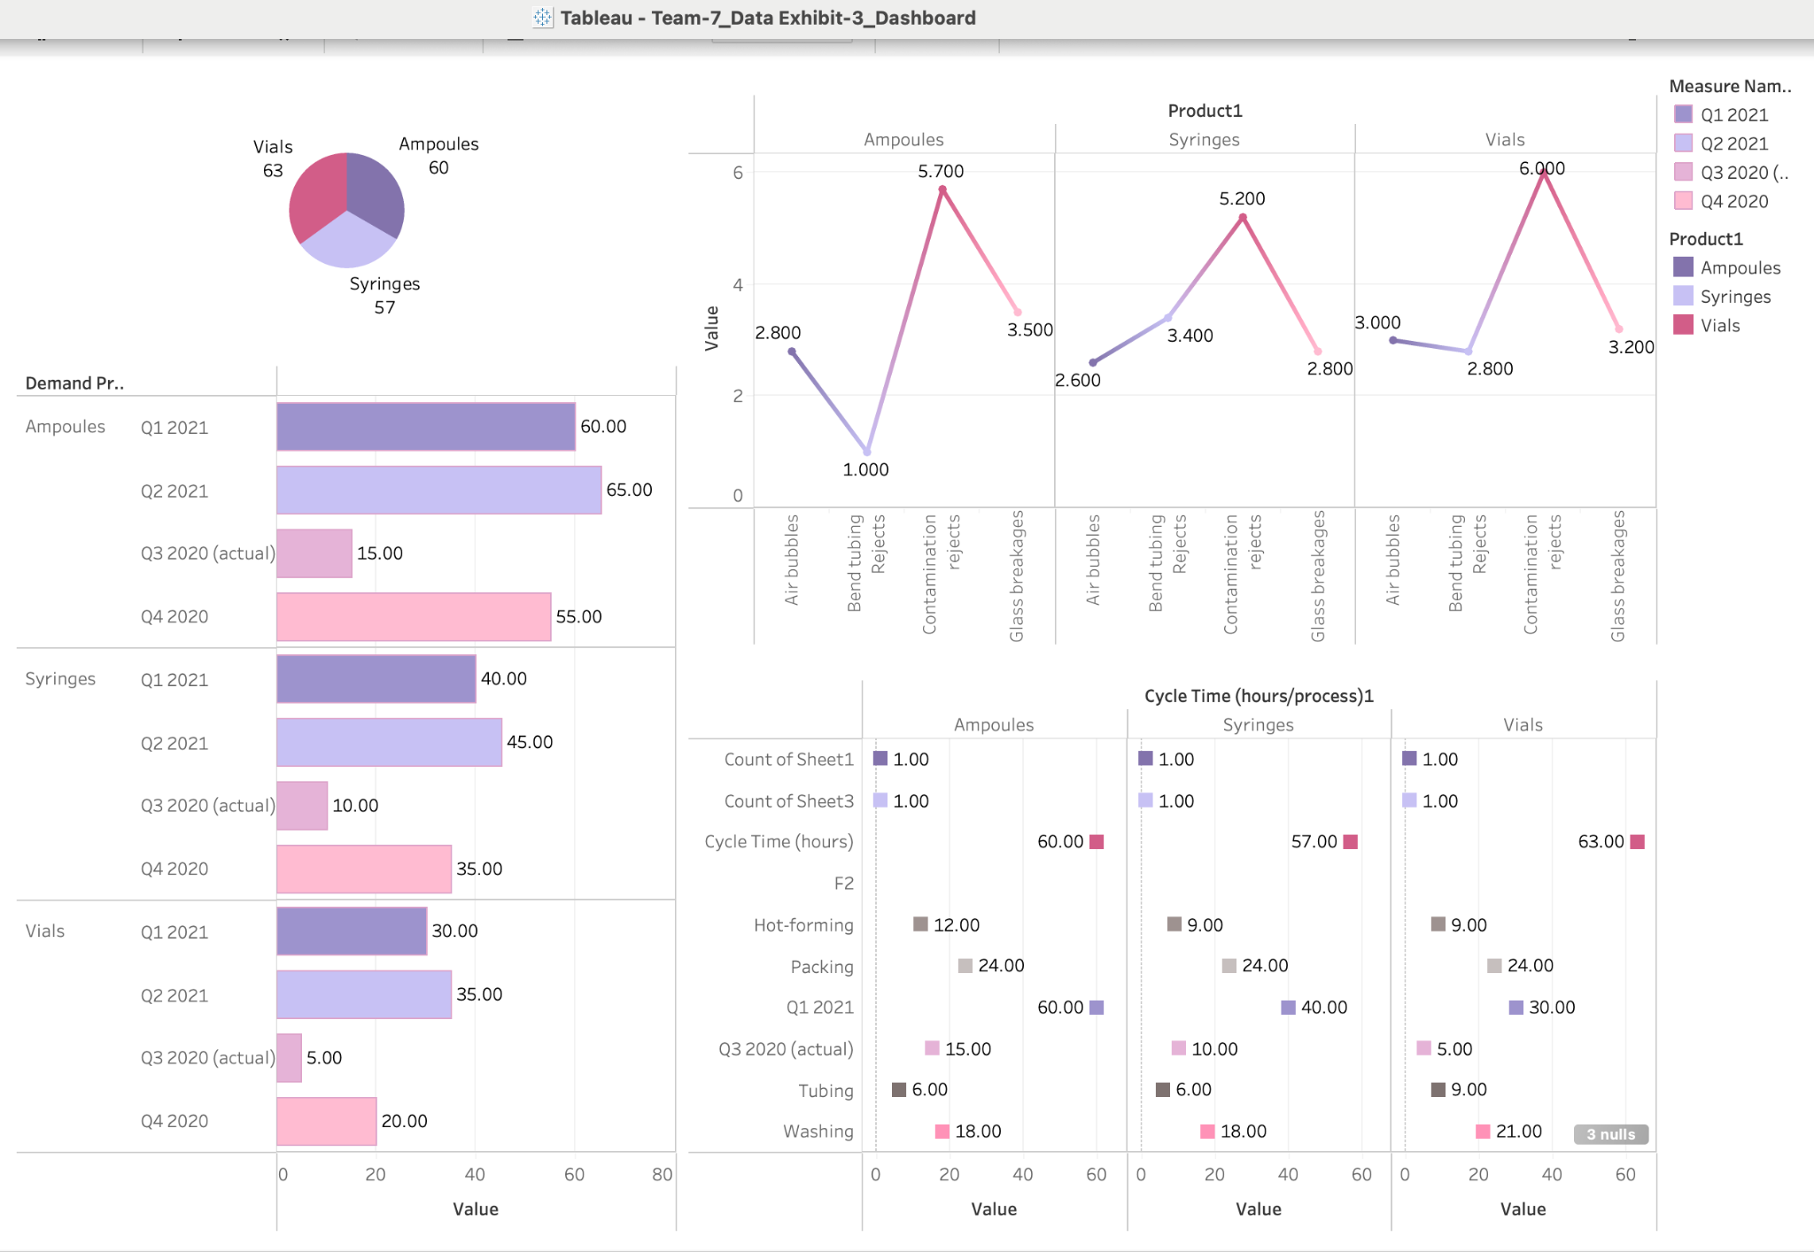

The third exhibit offers insights into the demand for fabricated goods and the intricacies of their production processes.

* The data exhibits a notable gap between the current demand and forecasted future demand, with future estimates potentially reaching up to 65 lots compared to current levels of 5 to 15 lots. This substantial difference underscores the necessity for improved demand forecasting methods to better align production with anticipated market demands.
* Detailed analysis of cycle times shows that packing is the most time-intensive process across all products, taking up to 24 hours. Moreover, contamination is identified as a primary cause of product rejections, significantly affecting product quality. Addressing these issues can lead to enhanced operational efficiency and product reliability.

**Recommendations**

Based on the comprehensive analyses, the following strategic recommendations are made to enhance overall operational efficiency and responsiveness:

1. Implement a more rigorous supplier evaluation framework that incorporates both financial stability (credit ratings) and operational security (data security ratings) to ensure a resilient and secure supply chain.

2. Adopt advanced inventory management systems, like JIT, to better regulate stock levels, particularly for SKUs with excessive inventory, thereby reducing holding costs and improving cash flow.

3. Utilize more sophisticated forecasting models to accurately predict market demands, thus enabling more precise production planning and inventory management.

4. Initiate targeted measures to reduce contamination rates and optimize the packing process, thus shortening cycle times and enhancing product quality and customer satisfaction.

By embracing these recommendations, the organization can expect to achieve improved supplier reliability, reduced operational costs, enhanced production efficiency, and better alignment with strategic goals and market demands.